MANZAR - THE MODEL ENACTUS VILLAGE
Project MANZAR aims to establish a model village, engaging the community to initiate sustainable development. This model village harbours sustainability and efficiency to bring forth socio-economic development.
The United Nations General Assembly prescribed 17 Sustainable Development Goals in 2015, these goals aim to holistically empower and mobilise the community towards a better tomorrow. Following the conception of these goals, Project MANZAR aims to incorporate productivity and empowerment in the
community.

The following goals are being fulfilled through our current operations:
- No Poverty
- Good Health and Well Being
- Quality Education
- Gender Equality
- Clean Water and Sanitation
- Decent Work and Economic Growth
- Industry, Innovation and Infrastructure
- Reduced Inequalities
- Sustainable Cities and Communities
- Peace Justice and Strong Institution
OPERATIONS
The current location of our operations is at Anand Parbat and Mundka.
Mundka
It is a district located in West Delhi with average population of 54,541. Project Manzar with it’s operations aims to uplift the quality of life of people living there by providing them various opportunities and facilities in the field of education, healthcare, employment etc.
VENTURES
Computer Labs
With this computer centre, we hope to provide the kids with the basic IT knowledge for them to be able to enter the world of technologies in the 3 month long course that is offered at the centre. A degreed professional is appointed to teach the students the basics of computer. The lab has been established in the region and is of a considerable area.
Stitching camp
This venture is established to empower the underprivileged women living in Mundka by providing them employment opportunities and making them independent. Regular training sessions are conducted for the beneficiaries and they are also engaged in various collaborations to maintain a concrete sales network. The women in the Stitching Camps make Cloth Bags which are of superior quality, that are then sold out to Companies to replace the harmful plastic bags given to consumers
PROSPECTIVE VENTURES
- Establishment of conventional school for the underprivileged communities in Mundka
We plan on building a school on a land of area 1400 Sq m, located in Mundka.
After our extensive survey visits in the region we learned that the children here struggle immensely due to the absence of proper functioning schools. The locality does have a few schools but they fail to impart proper education to the enthusiastic children of Mundka.
Swayam Welfare And Educational Trust is a dedicated organisation which wishes to make a great impact on the lives of these children. It already has a functioning play school in the region. In collaboration with Swayam, we are currently working on building the School for Mundka. We aim to provide quality education to the students by,
- Making their time spent in the classroom productive
- Providing vocational training to them
- Building a comprehensive curriculum so as to ensure efficient learning at the school
The school has a huge potential to grow because of the large area available and the support of several local authorities, community members, non profit organizations etc.
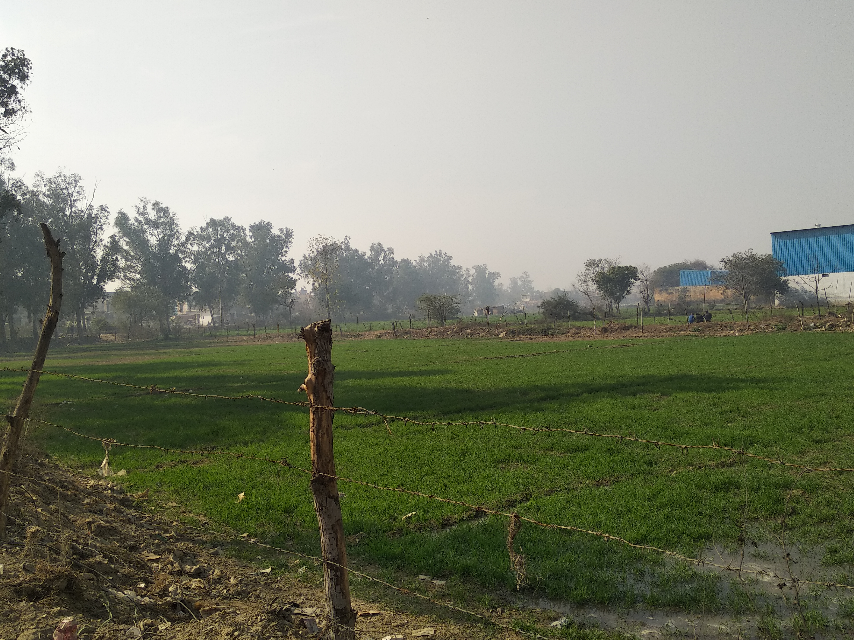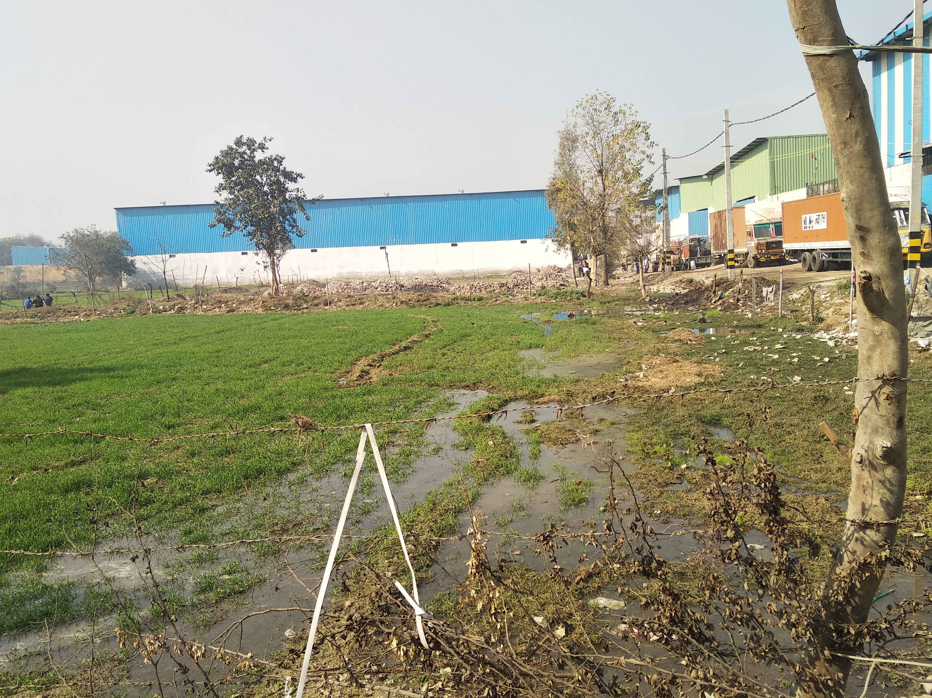

- Build a constructive Waste Management Model in the area to make it cleaner and promote awareness
After our Survey in the area, one pertinent issue that came up was of managing the waste that is openly dumped and causes fatal diseases.
Currently, this venture is at a very naissance stage where Segregation of Waste will be our first step towards making the area cleaner.

ANAND PARBAT
With an estimate population of two lakh people and over forty thousand households, Anand Parbat remains bereft of basic necessities such as healthcare, sanitation, primary education etc. A minuscule population of this community is employed in stable employments. The literacy rate, health index and employment opportunities are alarmingly low.
VENTURES
Project MANZAR amalgamates various projects undertaken by Enactus Ramjas to ensue sustainable and holistic development of the community. Project MANZAR combines a variety of ventures to have a holistic impact on the community and provide the people with basic facilities and new skills.
LIBRARY
The library is a cozy space where the children can fully immerse themselves in the art of reading and explore different worlds. Since the library shares its space with the soap production and stitching units, the mothers of the kids can also keep an eye on them.

STITCHING CAMP
Stitching Camps have been set up in order to provide employment to the women of Anand Parbat. The beneficiaries employed are provided with regular training and engaged in various collaborations to maintain a concrete sales network
BRIDGE SCHOOL
The Bridge School, as the name suggests aims to bridge the gap in the children's education that has arisen due to lack of access of education and it’s institutional. Through our need assessment survey, we identified students divided into different batches according to their age group and other relating factors.
Through integrated efforts, we engage the community to establish a sustainable community framework to initiate holistic development.
Various community networking sessions have been organised to apprise the audience about sanitation and healthcare. With combined efforts, the community was provided with certiﬁcation requirements to acquire government identiﬁcation.
Our intervention at Anand Parbat uplifted the community to establish a sustainable and efﬁcient model village. Project MANZAR aims to provide infrastructure and resources for further development in the community
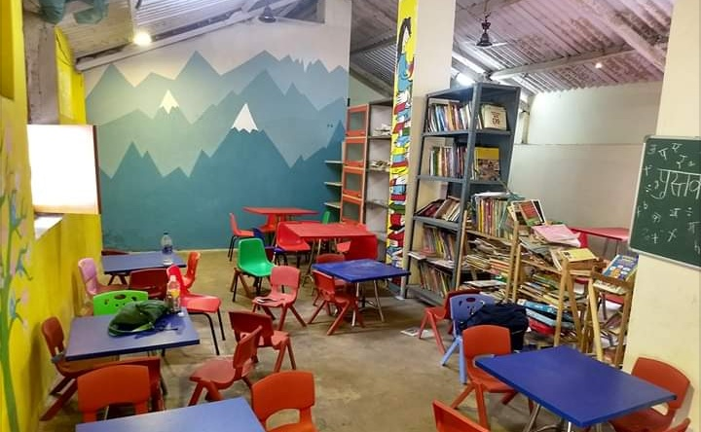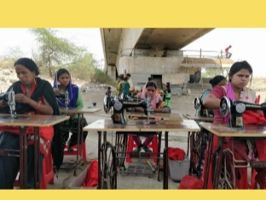

FUTURE GOALS
‣We aim to replicate the framework of a model village community in other various prospective locations facing critical hindrances that require immediate intervention and support. We aim to engage the community and initiate sustainable development to further develop, diversify and expand operations.
‣We aim to acquire further investment and sustainable collaborations for our current operations to further develop and diversify efforts at Anand Parbat and Mundka
‣We aim to fulfill the United Nations Sustainable Development Goals to empower community and reduce social barriers restricting socioeconomic development
‣We aim to increase community representation and engage larger audience to contribute towards community development and incorporate socio- economic sustainability

